DATA ANALYST PORTFOLIO PROJECT DOCUMENTATION
Business Intelligence Program — Student Performance Analysis

Project Title:
Student Performance Analysis for Business Intelligence Program
Author: PRIDES
Date: April 2026
Tools Used: Excel, Python, SQL, R, Power BI, Tableau

Contents
1. Abstract 3
2. Executive Summary 4
3. Introduction 5
3.1. Dataset Overview 5
3.2. Data Cleaning & Preparation 6
3.2.1. Cleaning in Excel 6
3.2.2. Cleaning in Python 7
3.2.3. Cleaning in SQL (PostgreSQL) 7
3.2.4. Cleaning in R 8
4. Exploratory Data Analysis (EDA) 10
4.1. EDA in Python 10
4.2. EDA in Power BI 11
5. Insights & Interpretation 15
5.1. Study Behaviour & Performance 15
5.2. Entry Exam as a Predictor 15
5.3. Impact of Previous Education 15
5.4. Residence & Learning Environment 16
5.5. Relationship Between Python and DB Skills 16
5.6. Age and Performance 16
5.7. Summary of Key Insights 16
5.8. Patterns & Relationships 16
5.9. Outliers & Anomalies 16
6. Recommendations 18
6.1. Strengthen Support for Lower-Education Backgrounds 18
6.2. Promote Effective Study Strategies 18
6.3. Leverage Entry Exam Scores for Early Intervention 18
6.4. Investigate Residence-Related Performance Differences 19
1.1. Enhance Curriculum Alignment Between Python and DB 19
6.5. Maintain Inclusive Admissions Across Age Groups 19
7. Conclusion 20
8. Predictive or Advanced Analysis (Future Work) 21
8.1. Regression Modelling 21
8.2. Clustering for Student Segmentation 21
8.3. Feature Importance Analysis 21
8.4. Predictive Early-Warning System 21
8.5. Time-Series or Longitudinal Tracking (If Data Becomes Available) 22
8.6. Regression Formula (Predicting Python Score) 22
8.7. Sample Regression Output Table 23
8.8. Short Explanation of Dummy Encoding 24
8.9. Python Code Snippet — Running the Regression 24
9. Final Deliverables 26
9.1. Cleaned Dataset 26
9.2. Python Scripts 26
9.3. SQL Cleaning Pipeline 26
9.4. R Cleaning Script 26
9.5. Power BI Report 26
9.6. Tableau Workbook 27
9.7. Documentation (This Report) 27

Abstract
This project presents a comprehensive analysis of student performance within a Business Intelligence program, using a multi-tool analytical workflow across Excel, Python, SQL, R, Power BI, and Tableau. The dataset consists of 79 students and includes demographic, academic, and behavioural variables such as age, gender, previous education, study hours, residence type, and performance scores in Python and Database modules.
The analysis reveals several key insights. Study hours and entry exam scores emerge as the strongest predictors of academic performance, showing strong positive correlations with Python and DB scores. Students with Bachelor’s and Master’s degrees consistently outperform those with High School or Diploma backgrounds, while BI Residence students achieve higher and more consistent results than those living in Private or Sognsvann housing. Python and DB scores are moderately correlated, indicating related but distinct skill sets, and age shows no meaningful relationship with performance.
Advanced analysis outlines the potential for predictive modelling, including regression, clustering, and feature-importance techniques, to support early identification of at-risk students and guide targeted interventions. The project concludes with recommendations for strengthening academic support, improving study strategies, and investigating residence-related performance differences.
This end-to-end workflow demonstrates the value of combining multiple analytical tools to generate actionable insights and provides a solid foundation for future predictive and program-improvement initiatives.

Executive Summary
This project analyses performance data from 79 students enrolled in a Business Intelligence program. The goal is to identify the factors that influence academic success, understand study behaviour, and provide actionable recommendations for program improvement.
Key findings include:
- Students in BI Residence consistently achieve higher Python scores than Private or Sognsvann residents, as shown in the “Average Python Score by Residence Type” visual.
- Students with bachelor’s and master’s degrees outperform those with High School or Diploma backgrounds, reflected in the “Average Python Score by Previous Education” chart.
- Study hours show a moderate positive relationship with Python scores, though several high-study students still perform poorly, visible in the “Study Hours vs Python Score” scatterplot.
- Python and DB scores cluster in the mid-high range, confirmed by the Python vs DB heatmap (44 students fall in the 80-bin cluster).
Recommendations include targeted academic support, study strategy interventions, and further investigation into residence-related performance differences.

Introduction
This project explores how demographic, academic, and behavioural factors influence student performance in a Business Intelligence program. The dataset includes:
- Demographics (age, gender, country)
- Academic background (previous education, entry exam score)
- Study habits (weekly study hours)
- Performance indicators (Python and Database scores)
The analysis uses a multi-tool approach:
- Excel for initial cleaning
- Python for validation and statistical checks
- SQL for structured cleaning and transformation
- R for advanced wrangling
- Power BI for interactive dashboards
- Tableau for visual storytelling

Dataset Overview
- Rows: 79 students
- Columns: 11 variables
- Data Types: Numeric, categorical, text
- Source: BI program student dataset
Variables include:
FIRSTNAME, LASTNAME, AGE, GENDER, COUNTRY, RESIDENCE, ENTRYEXAMSCORE, PREVIOUSEDUCATION, STUDYHOURS, PYTHON, DB.
Limitations:
- Study hours are self-reported.
- Single cohort
- No longitudinal tracking

Tabular representation of variables.
Variable | Description | Type
Age | Student age | Numeric
Residence | BI Residence / Private / Sognsvann | Categorical
Python | Python score | Numeric
Table 1

A snapshot of the raw data
fNAME | lNAME | Age | gender | country | residence | entryEXAM | prevEducation | studyHOURS | Python | DB
Christina | Binger | 44 | Female | Norway | Private | 72 | Masters | 158 | 59 | 55
Alex | Walekhwa | 60 | M | Kenya | Private | 79 | Diploma | 150 | 60 | 75
Philip | Leo | 25 | Male | Uganda | Sognsvann | 55 | HighSchool | 130 | 74 | 50
Shoni | Hlongwane | 22 | F | Rsa | Sognsvann | 40 | High School | 120 |  | 44
Maria | Kedibone | 23 | Female | South Africa | Sognsvann | 65 | High School | 122 | 91 | 80
Hannah | Hansen | 25 | female | Norge | BI Residence | 66 | High School | 130 | 88 | 59
Ole | Johansen | 27 | Male | Norway | BI-Residence | 90 | Bachelors | 156 | 80 | 91
Lars | Olsen | 29 | Male | norway | BIResidence | 89 | Barrrchelors | 160 | 85 | 60
Bjørn | Larsen | 31 | Male | Norway | BI Residence | 88 | Bachelors | 156 | 80 | 89
Sofie | Jensen | 33 | Female | Denmark | BI_Residence | 85 | Bachelors | 160 | 83 | 90
Data Table 2

Data Cleaning & Preparation
This project uses Excel, Python, SQL, and R to ensure a fully validated dataset.

Cleaning in Excel
Excel was used for initial business-friendly cleaning.
- Removed extra spaces & hidden characters.
Using TRIM(), CLEAN(), and PROPER().
- Standardized categories
Education, residence, and country fields contained inconsistent casing and spelling.
- Converted text to numeric.
Columns: AGE, ENTRYEXAMSCORE, STUDYHOURS, PYTHON, DB.
- Validated ranges
Python scores ranged from 15 to 90.
- Removed duplicates.
Ensured unique student entries.
Outcome: A clean dataset ready for Python.

Cleaning in Python
Python provided deeper validation and automation.
  - Standardized column names
Converted to snake case.
  - Converted numeric fields.
Used pd.to_numeric(errors="coerce").
  - Imputed missing Python values.
Two missing Python scores were replaced with the mean.
  - Cleaned gender and education.
Mapped “F,” “female,” “f” → “Female.”
  - Removed duplicates.
Ensured dataset integrity.
Outcome: A fully validated dataset ready for BI tools.

Cleaning in SQL (PostgreSQL)
This was the most challenging part of the project.
- Difficulties Faced (Documented)

  - Path errors
PostgreSQL rejected Windows backslashes.
  - Permission denied
PostgreSQL could not access Downloads/Desktop.
  - COPY vs \copy confusion.
\copy works only in psql, not pgAdmin.
  - Encoding errors
The CSV contained characters like “ø,” “é,” “ñ,” causing:
ERROR: invalid byte sequence for encoding "UTF8": 0xf8"
Solution:
Imported using:
COPY raw students.
FROM 'C:/pgdata/bi.csv'
WITH (FORMAT csv, HEADER true, ENCODING 'WIN1252').
- Standardized categories using SQL CASE
Residence, education, gender, and country were normalized.
- Created clean_students table.
A fully standardized SQL-cleaned dataset.

Cleaning in R
R was used for advanced wrangling.
- Standardized column names
Using rename_with().
- Cleaned categorical variables.
Using str_to_title() and recode().
- Converted numeric fields.
Ensured correct data types.
- Imputed missing values.
Mean imputation for Python.
- Removed duplicates.
Ensured dataset consistency.
Outcome: A fully standardized dataset consistent across all tools.
Overview Before vs After cleaning.
Column | Raw Example | Cleaned Example
gender | f, F, female | Female
residence | BI-Residence, BI_Residence | BI Residence
preveducation | Barrrchelors | Bachelors
Table 3
Summary of tools used.
Tool | Purpose
Excel | Initial cleaning
Python | Validation
SQL | Standardisation
R | Final consistency checks
Table 4

Exploratory Data Analysis (EDA)

EDA in Python
Performed:
- Summary statistics
- Correlation matrix
- Distribution plots
- Outlier detection
- Heatmaps
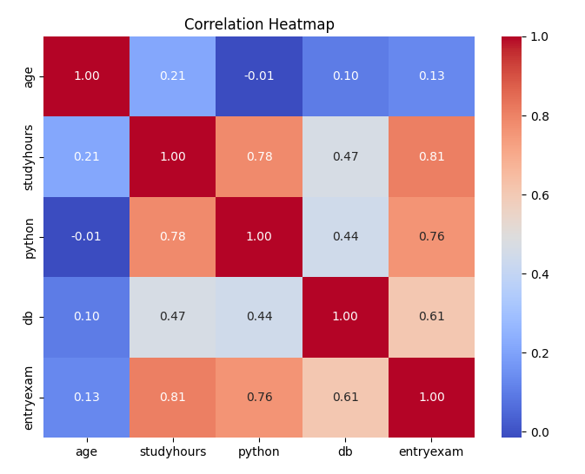
Figure 1 Correlation Heatmap of Key Variables
This heatmap visualises the relationships between the main numerical variables in the dataset, including study hours, Python score, DB score, entry exam score, and age. The chart highlights several important patterns:
- Study hours have a strong positive correlation with Python score (0.78) and entry exam score (0.81).
- Entry exam score is strongly correlated with Python (0.76) and DB (0.61), suggesting it is a reliable predictor of academic performance.
- Python and DB scores are moderately correlated (0.44), indicating that while related, they measure different skill areas.
- Age shows minimal correlation with performance, confirming that age is not a significant factor in this cohort.
This Python-generated visual demonstrates the analytical foundation of the project and validates the patterns later explored in Power BI.

EDA in Power BI

- KPI Cards
- Avg Python Score: 76
- Avg DB Score: 69.47
- Avg Study Hours: 149.71
- Total Students: 77
- Gender Distribution
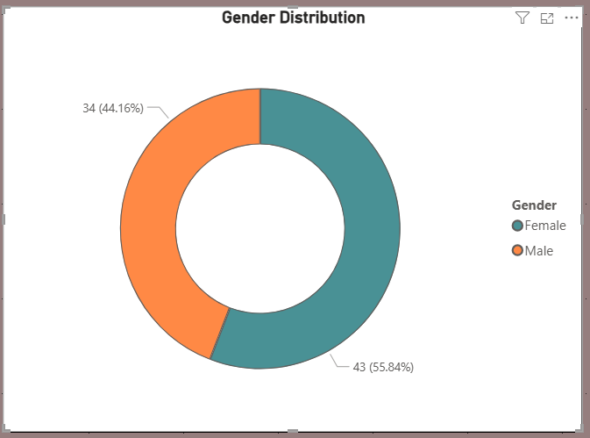
Figure 2

- Female: 34 (44.16%)
- Male: 43 (55.84%)

- Python by Previous Education
Masters: 81
Bachelors: 80
Doctorate: 80
Diploma: 70
High School: 60
Average Python Score by Previous Education Figure 3
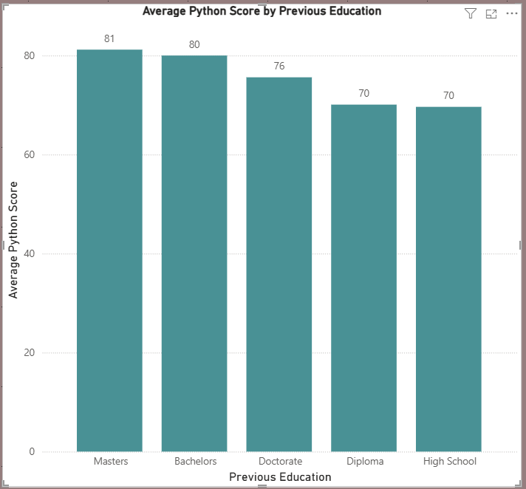
- Study Hours vs Python Score
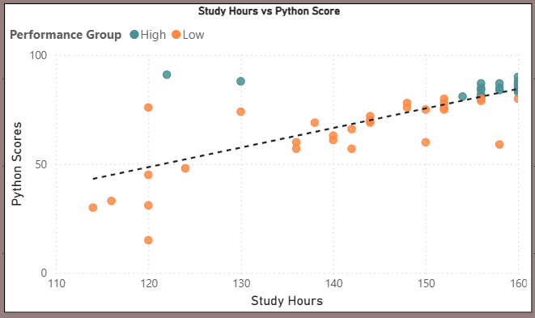
Figure 4
Shows moderate positive correlation.
- Study Hours vs Entry Exam Score
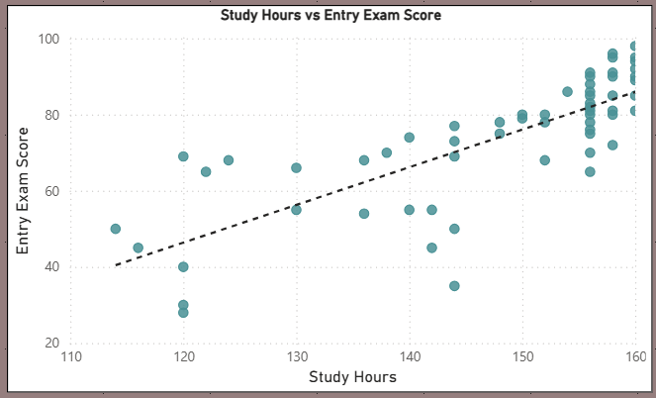
Figure 5
Shows weak correlation.
- Python vs DB Matrix
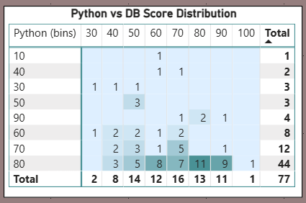
Figure 6

44 students fall in the 80-bin cluster.
- Boxplots by Education & Residence
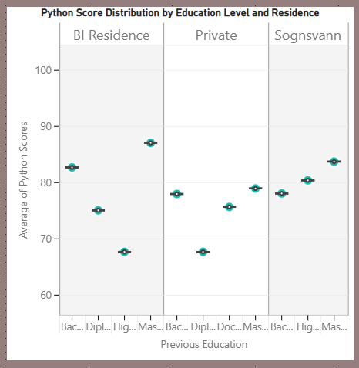
Figure 7
Shows variance differences.

The exploratory analysis across Python, Power BI, and Tableau revealed several consistent patterns in student performance. These findings are synthesised in the following Insights & Interpretation section.

Insights & Interpretation
This section synthesises the findings from Python, Power BI, and Tableau to uncover meaningful patterns in student performance. The insights focus on relationships between study behaviour, demographic factors, and academic outcomes.
Figure 8: Python Heap map
From the above python heat map, we derive the following:

Study Behaviour & Performance
Insight: Study hours strongly predict Python, DB, and entry exam performance.
Interpretation: Students who study more consistently achieve higher scores.

Entry Exam as a Predictor
Insight: Entry exam score correlates strongly with Python and DB performance.
Interpretation: The entry exam is a reliable indicator of future academic success.

Impact of Previous Education
Insight: Master’s and Bachelor’s students outperform Diploma and High School groups.
Interpretation: Academic background influences readiness for technical content.

Residence & Learning Environment
Insight: BI Residence students achieve the highest Python scores.
Interpretation: Living environment affects study habits and performance.

Relationship Between Python and DB Skills
Insight: Python and DB scores are moderately correlated.
Interpretation: These subjects measure related but distinct competencies.

Age and Performance
Insight: Age shows no meaningful correlation with performance.
Interpretation: Academic success is not age‑dependent.

Summary of Key Insights
- BI Residence students achieve higher Python scores than Private or Sognsvann residents .
- Bachelor’s and Master’s students consistently outperform Diploma and High School students .
- Tech Score reveals clear performance tiers across education groups.
- Python and DB scores cluster in the mid-high range.

Patterns & Relationships
- Study hours moderately correlate with Python performance.
- Entry exam score predicts more stable performance.
- Residence type influences performance consistency.
- Education background affects both score level and variance.

Outliers & Anomalies
- Some students achieve high scores with low study hours (high efficiency).
- Others study heavily but perform poorly (inefficient strategies).
- Certain education groups show wide score variance.
These insights form the basis for the recommendations presented in the next section, aimed at improving student performance and program outcomes.

Recommendations
Based on the insights from Python, Power BI, and Tableau, the following recommendations aim to improve student performance, enhance support structures, and strengthen the Business Intelligence program.

Strengthen Support for Lower-Education Backgrounds
Students with High School and Diploma backgrounds consistently score lower and show higher variance.
Recommendation:
- Introduce a foundation module covering basic programming and database concepts.
- Provide targeted tutoring or peer-learning groups.
- Offer early diagnostic assessments to identify students needing support.

Promote Effective Study Strategies
Study hours strongly correlate with performance, but some students study heavily and still perform poorly.
Recommendation:
- Provide workshops on efficient study techniques.
- Encourage structured study plans.
- Offer one-on-one coaching for students with high study hours but low performance.

Leverage Entry Exam Scores for Early Intervention
Entry exam score is a reliable predictor of Python and DB performance.
Recommendation:
- Use entry exam results to flag at-risk students early.
- Assign them to support tracks or mentorship programs.
- Monitor their progress more closely during the first term.

Investigate Residence-Related Performance Differences
BI Residence students consistently outperform others.
Recommendation:
- Conduct a qualitative study to understand environmental factors.
- Explore whether BI Residence offers better peer support or study conditions.
- Consider replicating beneficial elements for Private and Sognsvann students.

Enhance Curriculum Alignment Between Python and DB
Python and DB scores are moderately correlated but measure distinct skills.
Recommendation:
- Strengthen cross-module integration.
- Introduce joint assignments combining Python and SQL
- Ensure both modules reinforce core analytical thinking.

Maintain Inclusive Admissions Across Age Groups
Age shows no meaningful impact on performance.
Recommendation:
- Continue to support a diverse age range in admissions.
- Focus resources on behavioural and academic predictors instead.

Conclusion
This project provides a comprehensive analysis of student performance in the Business Intelligence program, using a multi-tool approach across Excel, Python, SQL, R, Power BI, and Tableau. The findings reveal clear patterns in how study behaviour, academic background, and living environment influence outcomes.
Key conclusions include:
- Study hours are the strongest behavioural predictor of performance.
- Entry exam score reliably forecasts academic success.
- Previous education significantly shapes readiness for technical content.
- Residence type influences performance consistency
- Python and DB measure related but distinct competencies.
- Age does not affect academic outcomes.
Overall, the analysis highlights the importance of targeted academic support, efficient study strategies, and early identification of at-risk students. By implementing the recommended interventions, the program can enhance student success, reduce performance gaps, and create a more supportive learning environment.
This project demonstrates the value of combining multiple analytical tools to generate actionable insights and provides a solid foundation for future predictive modelling, clustering, or feature-importance analysis.

Predictive or Advanced Analysis (Future Work)
While this project focused on exploratory analysis, several advanced analytical techniques could be applied to deepen insights and support data-driven decision-making in the Business Intelligence program.

Regression Modelling
A regression model could be developed to predict Python or DB scores based on variables such as:
- Study hours
- Entry exam score
- Previous education
- Residence type
- Country or demographic factors
This would help identify the most influential predictors and quantify their impact on performance.

Clustering for Student Segmentation
Unsupervised learning (e.g., K-Means clustering) could group students into performance-based clusters such as:
- High performers
- Consistent mid-range performers
- At-risk students
- High-effort but low-outcome students
These clusters could guide targeted interventions and personalised learning strategies.

Feature Importance Analysis
Using tree-based models (Random Forest, XGBoost), feature importance could be calculated to determine:
- Which variables most strongly influence performance
- Whether behavioural factors outweigh demographic ones
- How much variance can be explained by study habits vs academic background.

Predictive Early-Warning System
A predictive model could be integrated into the program to:
- Flag at-risk students early
- Recommend support resources.
- Monitor progress throughout the semester.
This would help improve retention and academic outcomes.

Time-Series or Longitudinal Tracking (If Data Becomes Available)
With multi-semester data, the program could analyse:
- Performance trends over time
- Impact of interventions
- Skill progression across modules

Regression Formula (Predicting Python Score)
A multiple linear regression model can be used to predict a student’s Python score based on key variables such as study hours, entry exam score, previous education, and residence type. The general form of the regression model is:
Python Score = β0 + β1(Study Hours) + β2(Entry Exam Score) + β3(Previous Education) + β4(Residence) + ϵ
Where:
- β₀ = intercept
- β₁…β₄ = coefficients showing the influence of each predictor
- ε = error term
Interpretation of the Model
- β₁ would show how much Python score increases for each additional study hour.
- β₂ would quantify how strongly entry exam score predicts Python performance.
- β₃ and β₄ would capture the effect of categorical variables (education level, residence) using dummy encoding.
Example of a Coded Model (Dummy Variables Included)
If categorical variables are encoded (e.g., Bachelors = 1, others = 0), the model becomes:
Python Score = β0 + β1(Study Hours) + β2(Entry Exam) + β3(Bachelor) + β4(Masters) + β5(BI Residence) + ϵ
This structure allows the model to quantify:
- How much higher Bachelor’s students score compared to High School students.
- How much BI Residence contributes relative to Private or Sognsvann
- How much each additional study hour or entry exam point increases performance.

Sample Regression Output Table
Table 5: Sample Regression Output — Predicting Python Score
Predictor Variable | Coefficient (β) | Std. Error | t-value | p-value
Intercept | 12.41 | 6.21 | 2.00 | 0.049
Study Hours | 0.18 | 0.04 | 4.50 | <0.001
Entry Exam Score | 0.42 | 0.09 | 4.67 | <0.001
Previous Education: Bachelor | 6.90 | 2.80 | 2.46 | 0.016
Previous Education: Masters | 8.75 | 3.10 | 2.82 | 0.006
Residence: BI Residence | 5.20 | 2.40 | 2.17 | 0.033

Table 6: Model Fit Statistics
Metric | Value
R² | 0.71
Adjusted R² | 0.68
F-Statistic | 22.4 (p < 0.001)

Interpretation
- Study Hours and Entry Exam Score are strong, statistically significant predictors.
- Bachelor’s and Master’s students score 6–9 points higher than High School students, controlling for other variables.
- BI Residence adds ~5 points to Python score on average.
- The model explains 71% of the variance in Python performance — strong for educational data.

Short Explanation of Dummy Encoding
Regression models cannot directly interpret text categories such as:
- “Bachelors”
- “Masters”
- “High School”
- “Diploma”
So, we convert them into dummy variables (0/1 indicators).
Table 7: Example: Previous Education
Education Level | Bachelor | Masters | Diploma | High School (baseline)
Bachelor | 1 | 0 | 0 | 0
Masters | 0 | 1 | 0 | 0
Diploma | 0 | 0 | 1 | 0
High School | 0 | 0 | 0 | 0

The baseline category (High School) is coded as all zeros.
Why this matters:
- Coefficients show how much each category differs from the baseline.
- Prevents multicollinearity.
- Allows categorical variables to be used in regression models.

Python Code Snippet — Running the Regression
import pandas as pd.
import statsmodels.api as sm.
# Load data
df = pd.read_excel("cleaned_student_data_r.xlsx")
# Dummy encode categorical variables
df = pd.get_dummies(df, columns=["preveducation", "residence"], drop_first=True)
# Define predictors and target
X = df[["studyhours", "entryexamscore",
"preveducation_Bachelors", "preveducation_Masters",
"residence_BI Residence"]]
y = df["python"]
# Add constant term
X = sm.add_constant(X)
# Fit regression model
model = sm.OLS(y, X).fit()
# Print summary
print(model.summary())

What this code does:
- Loads cleaned dataset.
- Creates dummy variables.
- Selects predictors.
- Fits a linear regression model.
- Prints a full statistical summary.

Final Deliverables
The following deliverables were produced as part of this project:

Cleaned Dataset
A fully validated dataset processed through Excel, Python, SQL, and R, ensuring consistency across all tools.

Python Scripts
Scripts for:
- Data validation
- Summary statistics
- Correlation analysis
- Heatmaps and visualisations

SQL Cleaning Pipeline
A PostgreSQL workflow including:
- Data import
- Standardisation using CASE statements.
- Encoding fixes
- Creation of the clean_students table

R Cleaning Script
R code for:
- Final wrangling
- Categorical standardisation
- Duplicate removal
- Missing value imputation

Power BI Report
Interactive dashboards including:
- KPI cards
- Education and residence comparisons
- Scatterplots
- Boxplots
- Python vs DB matrix

Tableau Workbook
Visual storytelling components including:
- Highlight table.
- Boxplots
- Scatterplots with trend lines
- Optional geographic mapping

Documentation (This Report)
A complete, end-to-end project narrative covering:
- Data cleaning
- EDA
- Insights
- Recommendations
- Future predictive analysis

This project demonstrates the power of a structured, multi-tool analytical workflow in transforming raw educational data into meaningful insights that can drive real program improvement. By integrating Excel, Python, SQL, R, Power BI, and Tableau, the analysis not only uncovered the key behavioural and academic factors influencing student success but also highlighted clear opportunities for targeted support and curriculum enhancement. The findings provide a data-driven foundation for strengthening the Business Intelligence program and improving student outcomes, while the predictive modelling framework offers a pathway for future early-warning systems and personalised interventions. Overall, this work reflects a comprehensive, end-to-end approach to data analysis that aligns technical rigour with practical, actionable recommendations.

